Contents
1. Project Overview 2
1.1 Introduction 2
1.2 Purpose 3
2. Objectives 3
3. System Architecture 4
3.1 Frontend (React.js) 4
3.2 Backend (Python Flask) 4
3.3 Machine Learning Models and Evaluation 4
Classification Model 4
Segmentation Model 5
3.4 Machine Learning Models Evaluation 5
Classification Model 5
Segmentation Model 6
4. Workflow 7
Diagram of Workflow: 8
5. Implementation Details 8
6. Web Application Results 9
7. Screenshots / Interface 10
Pages: 10
Features: 12
8. Challenges & Solutions 12
9. Future Work 12
10. Conclusion 13

Final Report: MRI Classification and Segmentation Web Application

1. Project Overview

1.1 Introduction
Brain tumors represent one of the most critical neurological conditions, with early detection and accurate diagnosis being essential for effective treatment and improved patient outcomes. Magnetic Resonance Imaging (MRI) is widely recognized as the preferred diagnostic tool due to its non-invasive nature and ability to capture detailed structural information. However, manual interpretation of MRI scans is time-consuming and often subject to variability between radiologists, which can lead to delayed or inconsistent diagnoses. These challenges highlight the need for automated, reliable tools that can support clinicians in identifying and analyzing brain tumors.
Recent advancements in deep learning and computer vision have opened new opportunities for automating medical image analysis. Convolutional neural networks (CNNs) and encoder-decoder architectures have demonstrated strong capabilities in both image classification and segmentation tasks. Transfer learning and pretrained models further enhance performance by leveraging features learned from large datasets, particularly beneficial when working with limited medical imaging data. Such approaches have shown promise in accurately classifying tumor types and precisely delineating tumor boundaries, which are critical steps in clinical decision-making.
In this research, I have developed a comprehensive, web-based deep learning application for brain MRI analysis that integrates both tumor classification and segmentation in a unified framework. The classification task was addressed using DenseNet121 models, including a fine-tuned pretrained version and a model trained from scratch, with a custom classification head to learn tumor-specific features. For segmentation, U-Net architectures were implemented, including a standard U-Net and a ResNet-based U-Net, trained with a combined Dice Loss and Binary Cross-Entropy loss and evaluated using Mean Intersection over Union (Mean IoU) and Dice scores. MRI images were preprocessed with grayscale conversion, CLAHE-based contrast enhancement, Gaussian noise reduction, normalization, and resizing to 224×224 for classification and 256×256 for segmentation.
The final system was deployed as a web application using a Flask backend to serve the models and a React/Node.js frontend for interactive visualization. Users can upload MRI images and receive real-time predictions, including tumor class labels and segmentation masks. Overall, this work demonstrates a complete end-to-end framework that bridges research and practical application, combining robust deep learning techniques, optimized preprocessing, and modern web technologies to provide an accessible, accurate, and scalable solution for automated brain tumor analysis.

1.2 Purpose
The purpose of this project was to develop a fully functional web application that integrates deep learning models for MRI classification and segmentation. The application aims to assist medical professionals in diagnosing brain tumors by providing:
- Accurate tumor classification.
- Segmented MRI images highlighting tumor regions.
- A user-friendly interface to upload, view, and manage patient data.
- Persistent storage of patient records with visual results.
This project bridges AI research and practical clinical application, allowing easy deployment of machine learning models in a real-world setting.

2. Objectives
In this work Brain MRI Dataset BraTS 2023 Challenge has used to train the model.
The main objectives of this project have been successfully achieved as follows:
- Deep Learning-based MRI Classification:
Developed a robust deep learning model capable of accurately classifying brain MRI scans into 4 tumor categories.
- Tumor Segmentation:
Implemented a segmentation model that effectively identifies and outlines tumor regions within MRI images, providing precise localization.
- Web Application Integration:
Designed and deployed a web application that allows users to upload MRI scans and instantly receive classification and segmentation results.
- Performance Evaluation:
Evaluated model performance using established metrics including accuracy, precision, recall, F1-score for classification, and Dice coefficient and IoU for segmentation, ensuring reliability and clinical relevance.
- User-friendly Interface and Reporting:
Developed an intuitive visualization and reporting interface, enabling easy interpretation of results for both clinical and research purposes.

3. System Architecture
The application is structured using a client–server model:

3.1 Frontend (React.js)
- Pages:
  - Upload MRI: Allows users to upload MRI scans.
  - Results Page: Displays classification and segmentation outcomes.
  - Patient Data Page: Shows saved patient records with images and metadata.
- Features:
  - Horizontal display of original and segmented images.
  - Modal windows for detailed image view.
  - Table view for patient data with refresh capability.
  - Professional styling with React components and CSS.

3.2 Backend (Python Flask)
- Handles API requests and responses.
- Endpoints:
  - POST /classify → Returns tumor type and confidence.
  - POST /segment → Returns segmented MRI images.
  - GET /get-patient-data → Returns all saved patient records.
- Manages:
  - Data storage in data/images/.
  - Metadata storage for each patient record.

3.3 Machine Learning Models and Evaluation

Classification Model
The classification model was designed to determine the tumor type of a given brain MRI scan. Specifically, it classifies images into categories such as Glioma, Meningioma, Pituitary, and No Tumor, providing a confidence score for each prediction to indicate reliability.
The classification pipeline used DenseNet121 as the backbone, implemented in two versions:
- Non-pretrained DenseNet121 – trained from scratch with random weight initialization.
- Pretrained DenseNet121 (fine-tuned) – initialized with ImageNet weights and fine-tuned for MRI classification.
A custom classification head was added, consisting of convolutional layers, dense layers, and dropout regularization, enabling the network to learn tumor-specific features. Training used the Adam optimizer, categorical cross-entropy loss, and early stopping based on validation accuracy. The learning rate was adjusted dynamically using ReduceLROnPlateau to optimize convergence.

Segmentation Model
The segmentation model was designed to highlight tumor regions in MRI scans, producing a segmented mask for visual inspection and quantitative analysis. Two architectures were implemented:
- Standard U-Net – trained on preprocessed MRI images with a resolution of 256×256 pixels.
- U-Net with ResNet backbone – enhanced version using a pretrained ResNet encoder for improved feature extraction and segmentation accuracy.
Both models followed an encoder-decoder architecture with skip connections to retain spatial information. The loss function combined Dice Loss and Binary Cross-Entropy (BCE) to optimize both pixel-level accuracy and overlap between predicted masks and ground truth. Models were trained for a maximum of 50 epochs with early stopping and checkpointing to prevent overfitting.

3.4 Machine Learning Models Evaluation

Classification Model
The classification model was evaluated using standard metrics including accuracy, precision, recall, F1-score, and visualized through confusion matrices. Training and validation performance were monitored using loss and accuracy curves.

Non Pretrained
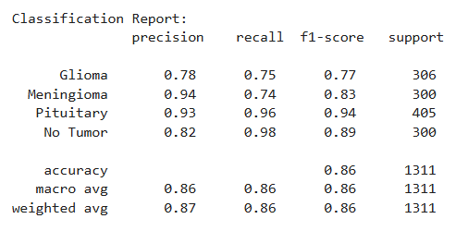

Pretrained (Fine Tuned)
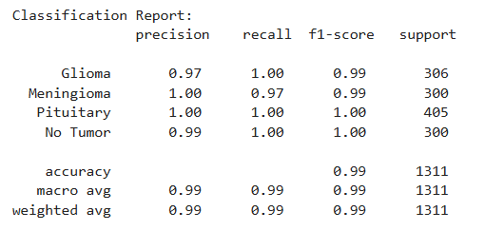

Segmentation Model
Segmentation performance was evaluated using:
- Mean Intersection over Union (Mean IoU)
- Dice Coefficient
- Visual inspection of segmented masks
Both models were tested separately to evaluate performance differences in terms of accuracy, segmentation quality, and computational efficiency. The results are summarized below:
Model | Test Accuracy | Test IoU | Test Dice Coefficient
U-Net (trained previously) | 0.90 | 0.08 | 0.15
U-Net with ResNet backbone | 0.96 | 0.22 | 0.36
The ResNet-based U-Net significantly outperformed the standard U-Net, achieving higher accuracy, IoU, and Dice scores. This confirms that leveraging a pretrained encoder improves feature extraction, resulting in more precise tumor delineation.
Overall, the results demonstrate that both the fine-tuned classification model and the ResNet-based U-Net segmentation model provide robust and reliable predictions, supporting real-time analysis within the web application.

4. Workflow
The system follows a streamlined workflow for automated brain MRI analysis, integrating both classification and segmentation models into a web-based platform:
- Image Upload:
  - The user uploads an MRI scan via the frontend interface.
Note: Users should upload MRI scans in standard medical imaging formats, preferably axial (top-side, prefrontal view), to ensure optimal performance and more accurate segmentation and classification results.
- Backend Processing:
  - The classification model predicts the tumor type and provides a confidence score to indicate prediction reliability.
  - The segmentation model generates a tumor mask, accurately highlighting tumor regions on the MRI scan.
- Data Storage:
  - The processed results, along with associated metadata (e.g., patient ID, timestamp, prediction details), are saved securely on the server.
- Result Visualization:
  - The frontend displays the original MRI image alongside the segmented mask for visual inspection.
  - The predicted tumor type and corresponding confidence score are presented clearly to the user.
- Patient Record Management:
  - All processed scans and results are stored as part of the patient’s record.
  - Users can access historical MRI scans and analysis results through the Patient Data Page, enabling efficient patient tracking and review.
This workflow ensures a seamless end-to-end pipeline, from image upload and automated analysis to result visualization and record management, providing an intuitive and reliable platform for MRI-based brain tumor assessment.

Diagram of Workflow:
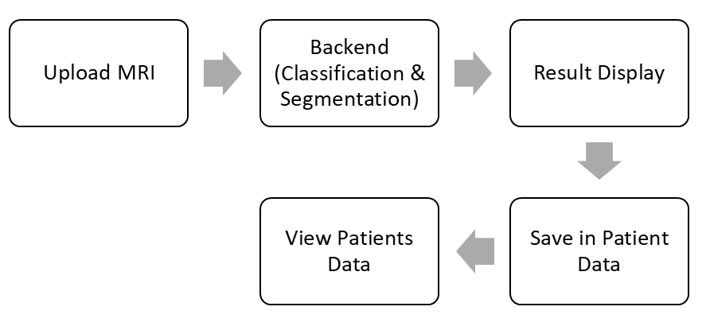

5. Implementation Details
5.1 Frontend
- Developed using React.js to provide a dynamic and responsive user interface.
- Axios is used for seamless communication with backend APIs.
- Patient data is presented in tables with alternating row colors for improved readability.
- Modal windows allow horizontal display of MRI images, enabling side-by-side comparison of original and segmented scans.
- A consistent footer and navigation bar are implemented across all pages to enhance user experience and maintain design uniformity.
5.2 Backend
- Developed using Flask, providing a lightweight and efficient API framework.
- Key endpoints handle:
  - File uploads from the frontend.
  - Running AI inference using pretrained and fine-tuned models.
  - Saving results and metadata for future reference.
- Processed images are stored in data/images/, with file paths recorded in metadata to facilitate easy retrieval and management.
5.3 Data Handling
- Each patient record contains:
  - Patient Name
  - Tumor Type
  - Confidence score of predictions
  - Date and Time of analysis
  - Original MRI image
  - Segmented MRI image
- All data is retrievable for historical analysis, comparisons, or auditing purposes, supporting longitudinal studies and clinical review.

6. Web Application Results
The developed web application effectively visualizes brain tumor segmentation results directly on MRI scans. Key outcomes include:
- Segmentation Overlay:
  - Tumor regions are accurately highlighted by overlaying the segmented mask directly on the original MRI image, allowing users to see tumor boundaries in context.
  - The overlay uses color-coded probability visualization to indicate model confidence:
    - Red: Probabilities above 90%, indicating highly confident tumor regions.
    - Magenta: Probabilities between 70–90%, indicating moderately confident regions.
    - Cyan: Probabilities below 70%, indicating uncertain or low-confidence areas.
- User Interface:
  - Images are displayed side-by-side or with overlay for easy inspection.
  - The interface is responsive and professional, enabling users to view results intuitively.
- Data Management:
  - Segmentation results are stored alongside the original MRI scans for retrieval and comparison.
  - Patient records can be accessed, and overlays can be reviewed for historical or longitudinal analysis.
This approach ensures clear and interpretable visualization of tumor regions, providing users with a reliable and interactive tool for analyzing MRI scans.

7. Screenshots / Interface

Pages:
- Upload MRI Page
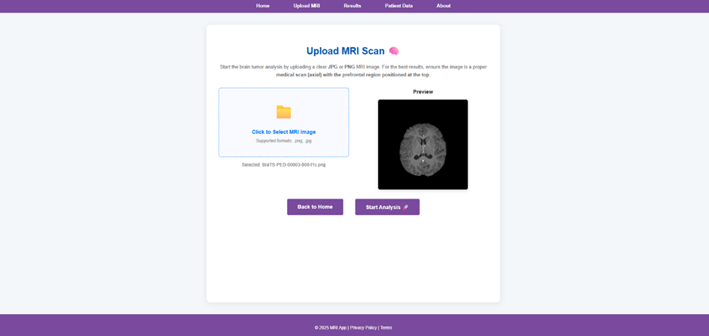
- Results Page
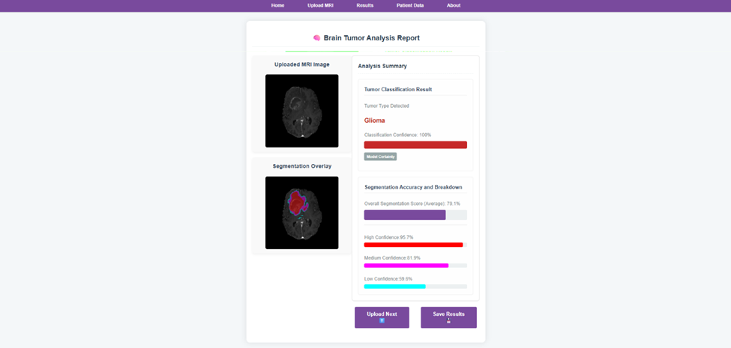
- Patient Data Saving popup
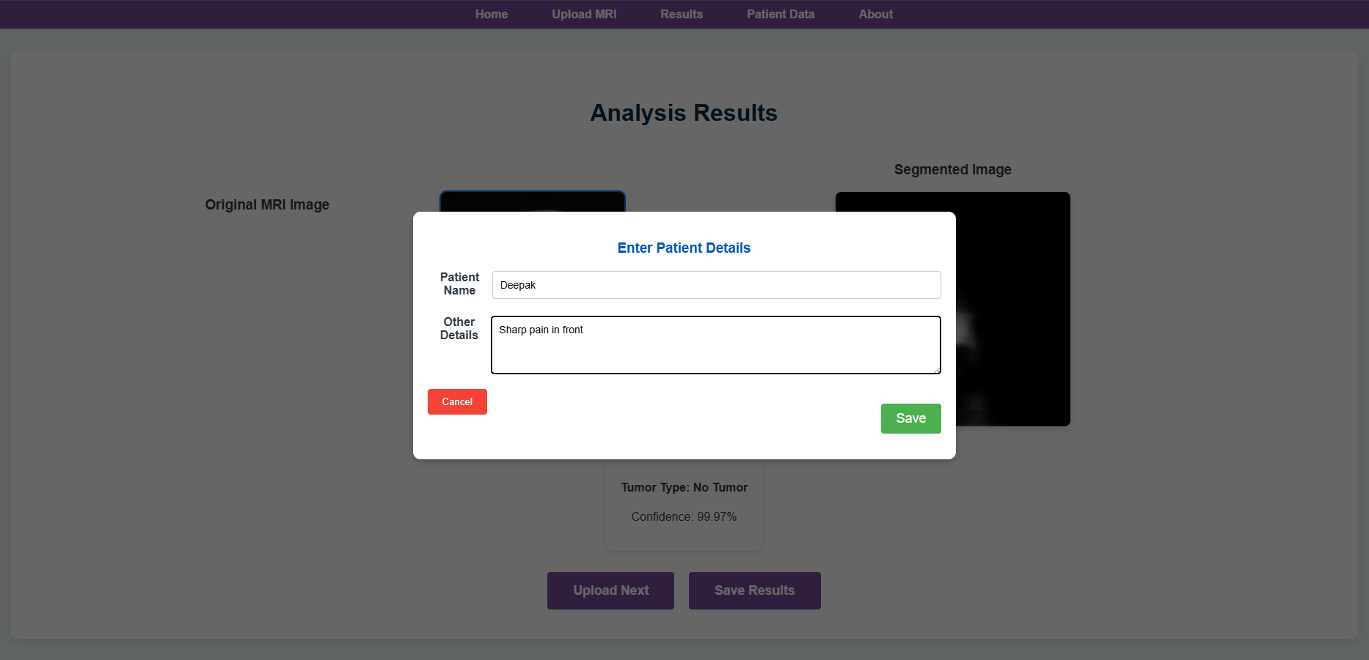
- Patient Data Page
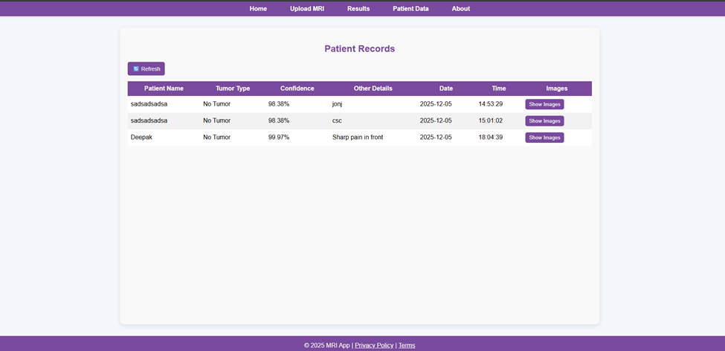

Features:
- Modal view for images.
- Horizontal layout for side-by-side comparison.
- Refreshable patient data table.
- Footer and navigation consistent on all pages.

8. Challenges & Solutions
Challenge | Solution
Aligning images horizontally in modal | Used flex-direction: row with flex-wrap: wrap
Storing large image data | Saved images on server; metadata saved in JSON
Frontend–backend integration | Used Axios for API calls, consistent path formatting
Responsive and professional UI | Used CSS, flexbox, and inline styling for layout and design

9. Future Work
- Advanced AI Models
  - Integrate multi-class tumor segmentation for more detailed analysis.
  - Apply domain adaptation and transfer learning to improve model generalization across diverse MRI datasets.
  - Fine-tune models on larger, aggregated datasets to enhance accuracy and reliability.
- Scalable Deployment
  - Extend the application to handle large-scale hospital or research datasets efficiently.
  - Implement cloud-based storage and processing to support high-volume data analysis.
- Enhanced Security & User Management
  - Add user authentication for clinicians and researchers to ensure secure access.
  - Implement role-based access control for data privacy and compliance.
- Performance Optimization
  - Optimize backend inference for faster processing of large datasets.
  - Utilize GPU acceleration and parallel processing for improved performance.
- Data Analytics & Visualization
  - Develop dashboards to display statistics on tumor types, prediction confidence, and patient trends.
  - Enable visualization of longitudinal data for research and clinical decision-making.
- Model Improvement & Research Expansion
  - Continuously update models by incorporating new MRI data from multiple sources.
  - Conduct experiments to improve segmentation accuracy and classification robustness.

10. Conclusion
This work successfully developed a comprehensive web-based deep learning application for automated brain MRI analysis, integrating both tumor classification and segmentation within a single platform. Using advanced preprocessing techniques, including grayscale conversion, CLAHE-based contrast enhancement, Gaussian noise reduction, normalization, and resizing, the dataset was optimized for reliable model training and inference.
The DenseNet121 classification model was fine-tuned with pretrained ImageNet weights, achieving robust tumor type predictions with high confidence, while the U-Net segmentation models, including a ResNet-based U-Net, accurately delineated tumor regions. The segmentation outputs were visualized as overlays on the original MRI images, with a color-coded probability map to highlight regions of varying model confidence, enhancing interpretability for users.
The web application, developed using a Flask backend and a React/Node.js frontend, enables users to upload MRI scans, view segmented overlays, and manage patient records efficiently. This end-to-end system demonstrates seamless integration of deep learning models with a responsive, user-friendly interface, providing a practical solution for automated brain tumor analysis.
Overall, this work establishes a robust, interpretable, and scalable framework for MRI-based tumor detection and segmentation, bridging the gap between research and clinical applications. It lays the foundation for future improvements, including advanced model optimization, multi-modal MRI analysis, and integration with hospital information systems, to further enhance accuracy, usability, and clinical impact.

